Project Design Phase-II
Data Flow Diagram & User Stories
Date | 28 SEPTEMBER 2026
Team ID | 6ab220cfbee0b08a2d2c63cd
Project Name | Auto Ticket Classification using FLOW DESIGNER
Maximum Marks | 4 Marks

Data Flow Diagrams:
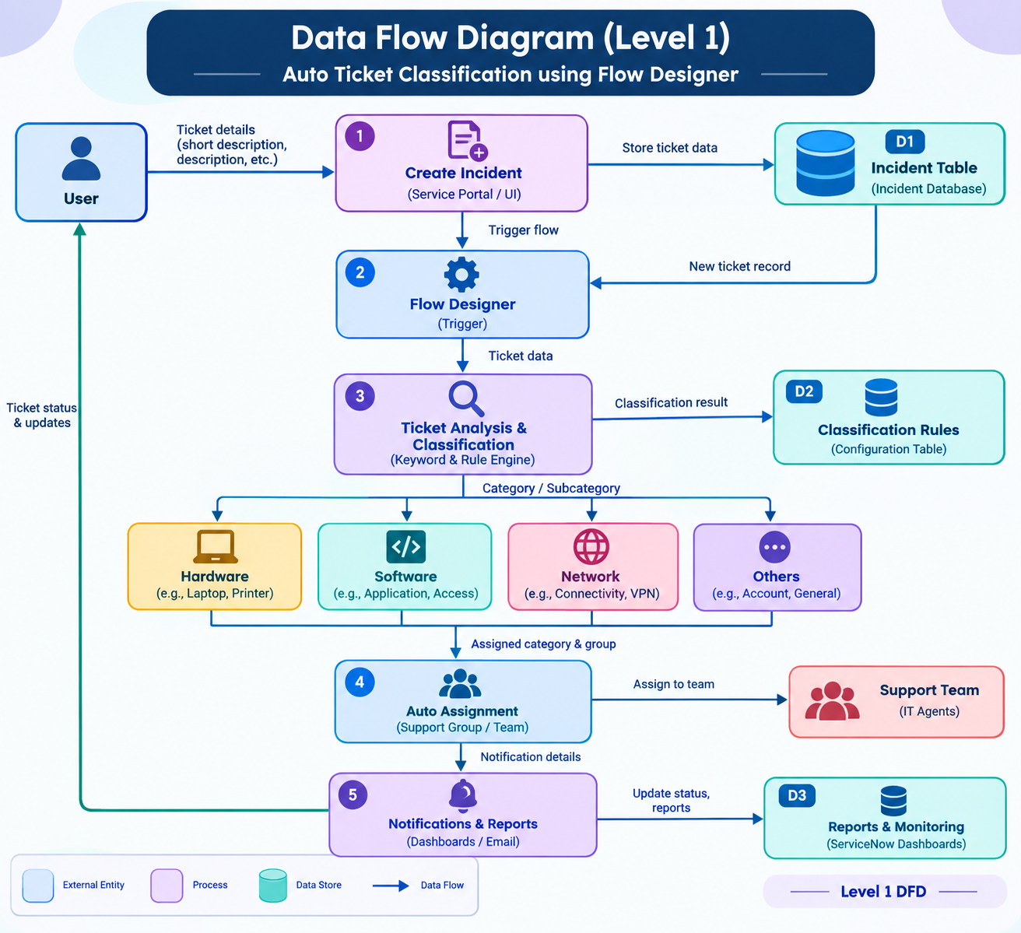

Explanation
- User creates an incident ticket.
- Ticket details are stored in the Incident Table.
- Flow Designer is triggered automatically.
- Ticket description is analyzed using classification rules.
- Ticket is categorized as Hardware, Software, Network, etc.
- Appropriate support team is assigned automatically.
- Notifications are sent to the assigned team.
- Reports and dashboards are updated.
User Stories
User Type | Functional Requirement (Epic) | User Story No. | User Story / Task | Acceptance Criteria | Priority | Release
End User | Ticket Creation | USN-1 | Create a new incident ticket. | Ticket created successfully. | High | Sprint-1
End User | Ticket Submission | USN-2 | Submit ticket through portal. | Ticket stored in Incident table. | High | Sprint-1
System | Flow Trigger | USN-3 | Trigger flow on ticket creation. | Flow starts automatically. | High | Sprint-1
System | Ticket Analysis | USN-4 | Analyze ticket details. | Keywords identified correctly. | High | Sprint-1
System | Classification | USN-5 | Classify ticket category. | Category assigned automatically. | High | Sprint-1
System | Assignment | USN-6 | Assign support group. | Ticket routed correctly. | Medium | Sprint-2
IT Agent | Notification | USN-7 | Receive assigned tickets. | Notification received. | Medium | Sprint-2
Admin | Rule Management | USN-8 | Manage classification rules. | Rules updated successfully. | Medium | Sprint-2
Admin | Reporting | USN-9 | View reports and dashboards. | Reports generated correctly. | Low | Sprint-3
Manager | Monitoring | USN-10 | Track ticket performance. | Metrics displayed correctly. | Low | Sprint-3

